# Sprint retrospective

**Good**:

* A clear workflow and task assignment
* Sprint plan matches with our team affect
* Requirements and sprint scheduling is updated frequently
* Well communication
* Good code commitment via Github
* Balanced progress between frontend and backend
* Great software development works

**Not Good:**

* Insufficient communication between teammates.
* Not all teammates take the responsibility for their own works and finished on time
* Too much time spent on bugs

**Improvement:**

* Setup a schedule plan at the beginning
* All teammates followed the plan well
* Improved frequency of frontend and backend meetings

**Conflict**

* + In the login page, a conflict has occurred over the use of accounts for login. Some members think using email addresses to login, but others think using names is better.
    - Through discussion, we finally decided to use email address, since username may be duplicated and emails are more identifiable
  + Initially some of the team members believe both standard employees and administrators should use the same login front instead of using separate login front.
    - After discussion of the advantages using separate login front (both improve user experience and more convenient to implement)
  + Team mates hold different opinions about the user profile information (e.g. whether ‘value stream’ or ‘name’ should be edited by standard employee itself or administrator)
    - We substitute ourselves into the positions of employee and administrator, we select appropriate attributes (such as phone number and notes)that could be edited by the employee itself while the other user information should be managed by the administrator.
  + About whether to use navigation or not, some teammates think it’s necessary and some of them don’t think so.
    - We decided use it because we think it adds on clarity and improves the user experience

**Collaboration**

Our team holds meetings everydays and it usually lasts for 3-5 hours. We assign ourselves into breakout rooms and we are either coding or helping others to solve bugs. We frequently push and pull the newest version of code from github and we actively develop and contribute to it.

**Zoom screenshots**

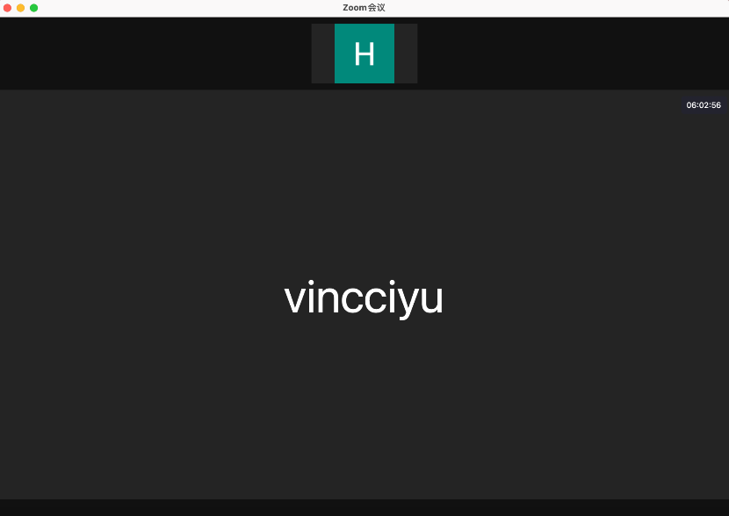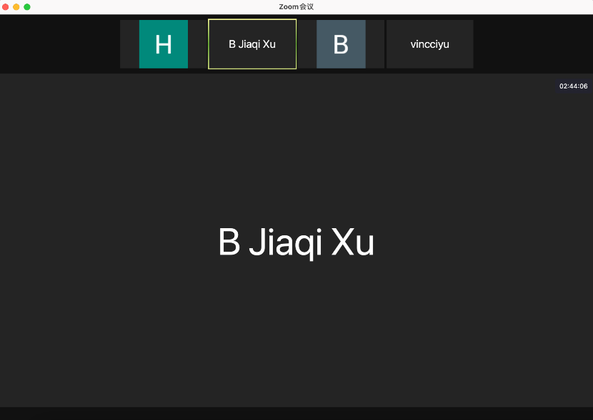

As soon as the front end starts to implement the web page, the backend starts to implement the functionalities corresponding to that web page. Through the active communication and cooperation between frontend and back end, we maintain both the quality of our code and efficiency.

Contributions to main, excluding merge commits and bot account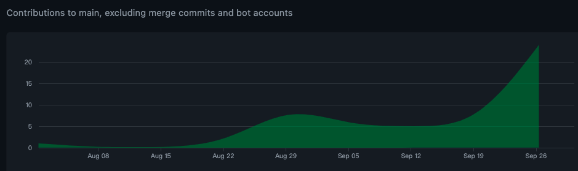

**Bugs**

Throughout the project so far, we've encountered a lot of bugs. First, we’ll try to figure it out ourselves (using Google to find information to solve the bugs). When we cannot solve the bug independently, we will discuss it together. Most bugs can be fixed in this way.

* When we try to do the pagination, at first, it is not rendered as we would like it to be (4 personal information per row and 1 page 2 rows). It just shows in one row and beyonds the entire interface. Two of the front-end members try it for several hours and still cannot figure it out. It took us a long time to Google to fix the bug.
* Another example is when we try to transmit data (by fixing a parameter) and link to another interface, it never works. Also, both front-end members and back-end have encountered this problem. We discussed it for a long time and finally, we worked it out by keeping trying.